Contents

Abstract 2

Key-words 2

Introduction 2

Related work 2

SYSTEM OVERVIEW 3

Hardware 3

Runtime and Maneuvering 3

Sensors and computing 3

Software 3

V-SLAM technology 4

PID auto leveling. 4

Object detection and Identification 5

Software In-Loop Simulation 5

Acknowledgement 6

Bibliography 6

# Abstract

In the maritime world, operations are divided into two categories: inspection, and action. this paper discusses the development of a hybrid underwater vehicle (HUWV) that combines the features of autonomous under-water vehicles (AUV) and remotely operated vehicles (ROV). this can be configured with multiple sensors beside cameras that use visual-simultaneous localization and mapping (V-SLAM) Technology and maneuvered by an intuitive platform. The vehicle is designed for use across several sectors, including underwater research, environmental assessment. When running the vehicle in autonomous mode, all missions are operated using artificial intelligence (AI) control, taking feedback from available sensors on board. Additionally, the vehicle runs Robot Operating System (ROS), enabling the vehicle to be piloted and tested using software-in-loop modelling with Gazebo& rviz based on UUV Simulator.

## Key-words

# Introduction

Robot Operating System (ROS) [1] took a big portion in the rapid development of a wide variety of software libraries, simulation platforms, and hardware add-ons dedicated for several uses of indoor & outdoor robotics operations [2]. On other side, Underwater vehicles played a major role in the environmental, commercial, military, and emergency operations. unmanned vehicles are divided into two types: manually operated and self-driving with their different uses [3]. the project aims to combine the advantages of the two types and reduce the cost of operating and manufacturing them. The hybrid vehicle should be able to produce maps of maritime life underwater and analyze their ecological status using use visual-simultaneous localization and mapping (V-SLAM) technology [4], and other object detection technologies [5]. The project also includes designing an integrated Underwater vehicle simulation platform through which we can test command and control systems in various marine environments such as high currents and polluted environments to avoid the problems that the submarine may encounter in the working environment, and this feature is needed by everyone who works in the field of autonomous vehicles. On the military level, the hybrid underwater vehicle (HUWV) will be able to conduct survey patrols of the depths of water. The vehicle qualifies it to carry out military operations using the automatic or autonomous command system.

## Related work

There were several projects that adopt the idea of implementing features of AUV’S and ROV’s, some of these projects come under the high cost- Large size category for

# SYSTEM OVERVIEW

While designing the HUWV the main aim was to reach an underwater robotics research platform. The design is separated into three disciplines: mechanical, electrical, software. The mechanical design facilitated interlocking acetal sheets, and acrylic tubing for insulation. The electrical system consists of the power circuit, and the data circuit shown in Figure XX. Power is supplied via the tether with optional batteries on-board for verifying vehicle dynamics and software independent of the tether. The software is based on a collection of open-source libraries under the ROS framework with access to software-in-loop simulations in Gazebo.

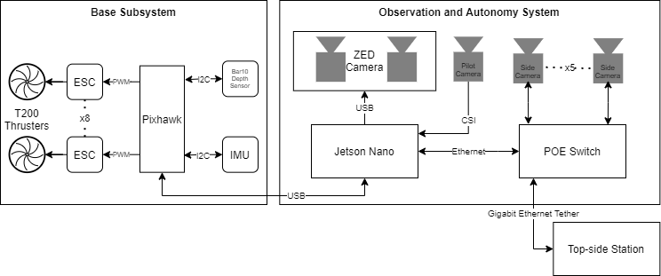

## Sensors and computing

The sensors and computing hardware is consisted of incorporates ZED 2K stereographic camera, 3 IP Cameras that provide clear vision for sides, bottom and front of the vehicle. In addition to an anti-vibration IMU sensor that locates the orientation of the vehicle, as well as BlueRobotics BAR03 pressure sensor which provides precise identification for the depth of the vehicle.

The system is connected to Nividia Jetson Nano which has been selected for its AI processing capabilities.

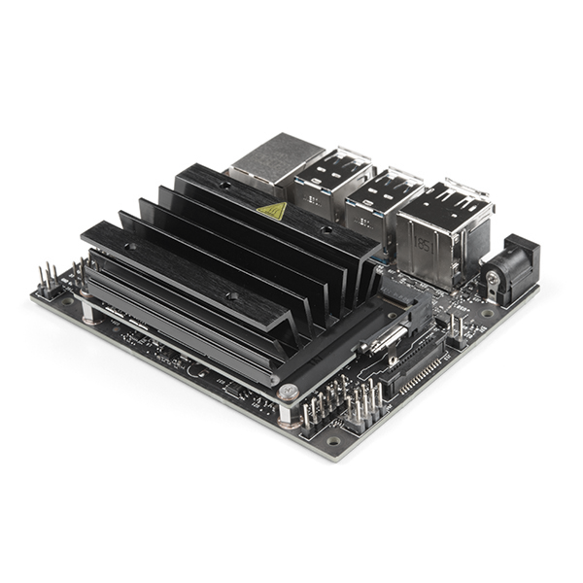

# Software

The control system of the HUWV is ROS based, where the system is consisted of a set of “Nodes”, each node represents a code related to a specific subsystem in the vehicle.

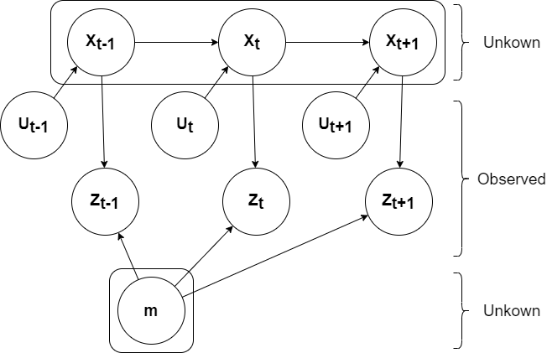

As shown in figure, different ROS nodes communicate together and integrate data to perform the desired mode of operation. In the HUWV case, feedback data received from ZED camera, and other cameras installed on vehicle, in addition to IMU sensors, set the intelligent action of the vehicle, this action is directed to the PIXHAWK controller that provides order to thrusters to perform the manoeuvring decision. The challenge is in the smoothness of data transmission between different ROS nodes, and how the GPU would act upon pre-set intelligent algorithms.

## V-SLAM technology

The SLAM can be defined as follows: given the robot’s controls *U,* the observations of the world *Z* determine the map of the environment *M,* and the robot’s pose *X*.

And in the probabilistic world as every element exhibits some errors, it can be expressed as:

$$p\left(x_{0:T}, m \right| z_{1:T}, u_{1:T})$$

It can also be represented as a flow diagram as in Figure ‎0 Flow diagram of a typical SLAM algorithm.Figure ‎0.

Figure ‎0 Flow diagram of a typical SLAM algorithm.

Another important aspect of SLAM is that filters ought to be used since the robot is always operating under the assumption of being inside a distribution of errors. Kalman filters are used here as the error distribution can be Gaussian, particularly the Extended Kalman Filter as underwater robotics often experience non-linear motion models.

Upon the general idea of SLAM technology, ZED 2K Stereoscopic Camera convert the visual data into laser-based chart. Which is identified by its relative node in the ROS system.

## PID auto leveling.

The aim of this function is to keep the vehicle vertically and horizontally stable as much as possible by using the Blue Robotics pressure sensor to calculate the depth & orientation of the vehicle, which gives the pilot an advantage when doing several in the ROV mode - tasks on the same depth by changing the desired depth on the graphical user interface (GUI) input box. Using the pressure Equation(2). pressure can be easily converted to depth where p denotes pressure, d denotes density, g denotes gravity's acceleration, and h denotes depth.

$$P= ρ*g*h$$

For the orientation of the vehicle, the IMU provides clear data for the ROS system to identify the HAUV status underwater, this is maintained within the IMU-ROS node using the PID control method that provides stable and smooth control upon the desired sampling rate. The following flowchart declares the mode of operation of the IMU-ROS node.

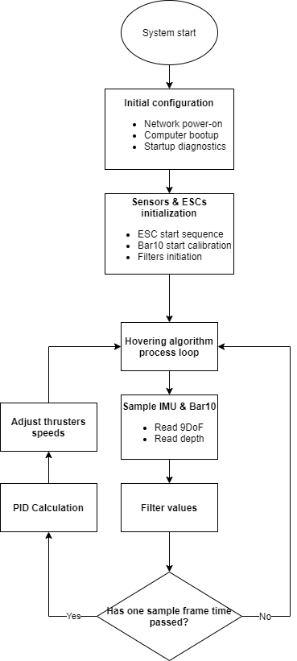

## Object detection and Identification

[Grab your reader’s attention with a great quote from the document or use this space to emphasize a key point. To place this text box anywhere on the page, just drag it.]

Object recognition is one of the features that, if implemented properly, will greatly enhance the technology of a HUWV in the field of work. This is due to the many applications in which it can be used to replace human divers, whether for protection or to save time.

## Software In-Loop Simulation

In the process of designing control systems, a simulation model may be a very useful method. On a simulation model, the control system can be tested, which is both much cheaper and easier than if the control system could only be tested in the actual process. For a simulation model, the system's stability is easily checked since the disruptions and atmosphere can easily be modified. In such a method, the key challenge is to make the simulation model as real as possible. There are several components that lead to the final force working out of the water on the vehicle. and when creating a simulation model, the most important ones should certainly be considered. [6]

The goal is to develop the foundations of ROV&AUV simulation platform. Two primary elements, a simulator, and a control system, will consist of the platform. Dynamic ROV simulations will be provided by the simulator, including versions of the various sensors.

The control system will be the ROV control program which will contain: an estimator, a path planner, a guidance system, and a controller. The aim is that, when the software is used on the real vehicle, the simulation platform will provide a framework for evaluating control software without significant modifications necessary. [7] The following figure shows a block diagram for the software system design. 

Without manually testing the vehicle in service, the platform can be used for testing applications for vehicle operations and missions. It will be tested on a with simulated sensor performance during the production of the control system. The program will be checked with the individual ROV in the loop when the production is completed. Based on thruster inputs and environmental parameters, the simulation platform must be able to replicate ROV motions. This requires a practical calculation of the hydrodynamic forces acting on the ROV, as well as a realistic estimate of the thrust forces for each propeller for a given number of revolutions per minute (RPM).

The appropriate components for the simulation of ROV systems, including sensor models with all possible add-ons such as sonar and Doppler velocity logs (DVL), an estimator, a route planner, a guidance system, and a controller, must be used in the control system section of the simulation platform. The platform is designed to be module oriented, where a particular role is performed by each module. Modules communicate with each other and, if needed, one module can be replaced with another module of the same kind. If a user needs to try a new controller algorithm, a realistic example of this is that they should substitute the controller module with their controller module on the simulation board, where the new algorithm is applied.



# Acknowledgement

The authors wish to thank the Academy of Scientific Research and Technology (ASRT), Egypt, Arab Academy for Science and Technology (AAST), Egypt, and Underwater Robotics Research center (UWRC), Egypt for their unlimited financial and motivational support and guidance.

# Bibliography

|  |  |
| --- | --- |
| [1] | K. C. B. G. J. F. T. F. J. L. M. Quigley, "Ros: an open-source robot operating system," in *ICRA workshop on open source software, vol. 3, no. 3.2.*, Kobe,Japan, 2009. |
| [2] | E. L. Antonella Wilby, "Low-Cost, Open-Source Hovering Autonomous Underwater Vehicle (HAUV) for Marine Robotics based on BlueROV2," in *OES Autonomous Underwater Vehicles Symposium (AUV)(50043)*, San Diego, California, 2020. |
| [3] | F. Eren, "Pose Detection and control of unmanned underwater vehicles -utilizing an optical detector array," University of New Hampshire, Durham, 2015. |
| [4] | S. R. M. G. D. M. a. R. L. A. Manzanilla, "Autonomous navigation for unmanned underwater vehicles: Real-time," *IEEE Robotics and Automation letters,* vol. 4, p. 1351–1356, 2019. |
| [5] | A. M. A. A. A. S. P. Y. Y. S. A. A. S. M. M. E. Y. J. M. Y. O. A. E. Z. M. H. Ahmed Khaled Osman, "Building ROS-based Software for an Autonomous Underwater Vehicle (AUV)," Ain Shams University (Unpublished), Cairo, Egypt, 2019. |
| [6] | S. A. S. M. V. L. D. T. R. Musa Morena Marcusso Manhães, "UUV Simulator: A Gazebo-based Package for Underwater Intervention and Multi-Robot Simulation," OCEANS’16 MTS/IEEE Monterey, Monterey, 2016. |
| [7] | s. M. Mo, "Development of a simulation platform for ROV systems," NTNU, Trondheim, 2015. |
| [8] | G. L. N. A. D. a. L. S. Echeverria, "Modular open robots simulation engine: MORSE," pp. 46-51, 2011. |
| [9] | I. Rist-Christensen, "Autonomous Robotic Intervention using ROV," NTNU, 2016. |
| [10] | C.-J. Wu, "6-DOF Modelling and Control of a Remotely operated vehicle," Flinders University , 2018. |
| [11] | A. A. O. ,. S. A. A. ,. S. A. M. Samer A Mohamed, "Dynamic Model and Control of an Autonomous Underwater Vehicle," International conference on Innovative Trends in Communication and computer engineering (ICTE), Cairo, 2020. |